Problem Statement

1) Considering age groups of < 20 , 20-35, 35 > ,Which age group spends the most

amount of money travelling.

2) What is the amount spent by each age-group, every year in travelling?

**Solution**

Below data sets are used for this assignment



Below that, we are loading the dataset nto the spark context

var baseRDD1 = sc.textFile(“/home/acadgild/Dataset_Holidays.txt”)

var baseRDD2 = sc.textFile(“/home/acadgild/Dataset_Transport.txt”)

var baseRDD3 = sc.textFile(“/home/acadgild/Dataset_User_details.txt”)

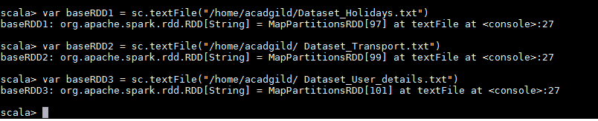

importing the singleton object for controlling the storage of RDD ,

import org.apache.spark.storage.StorageLevel

baseRDD1.persist(StorageLevel.MEMORY_ONLY)

baseRDD2.persist(StorageLevel.MEMORY_ONLY)

baseRDD3.persist(StorageLevel.MEMORY_ONLY)

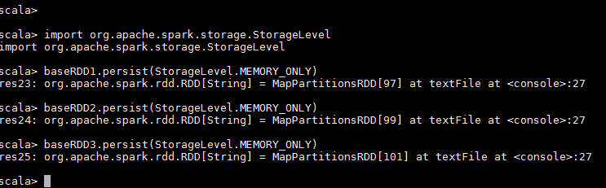

**Loading of datasets into name of holidays, transport and user RDD’s**

val holidays = baseRDD1.map(x=>(x.split(“,”)(0).toInt, x.split(“,”)(1), x.split(“,”)(2), x.split(“,”)(3), x.split(“,”)(4).toInt, x.split(“,”)(5).toInt))

val transport = baseRDD2.map(x=>(x.split(“,”)(0), x.split(“,”)(1).toInt))

val user = baseRDD3.map(x=>(x.split(“,”)(0).toInt, x.split(“,”)(1),x.split(“,”)(2).toInt))

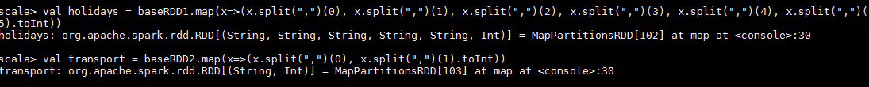



**1) Considering age groups of < 20 , 20-35, 35 > ,Which age group spends the most**

**amount of money travelling.**

val agemap = user.map(x=>x._1->

{

If (x._3<20)

“20”

else if (x._3>35)

“35”

else “20-35”

})

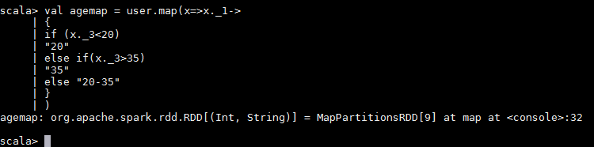

val usermap =holidays.map(x=>x._4->(x._1,x._5))

val transportmap=transport.map(x=>x._1 ->x._2)

val joinCost =usermap.join(transportmap)

val calCost =joinCost.map(x =>x._2._1._1 ->x._2._1._2*x._2._2)

val groupCost =calCost.groupByKey().map(x=>x._1 ->x._2.sum)

val groupAgeCost = agemap.join(groupCost).map(x =>x._2._1 -> x._2._2)

val finalCost = groupAgeCost.groupByKey().map(x => x._1 -> x._2.sum)

val maxVal = finalCost.sortBy( x => -x._2).first()

**output screen**

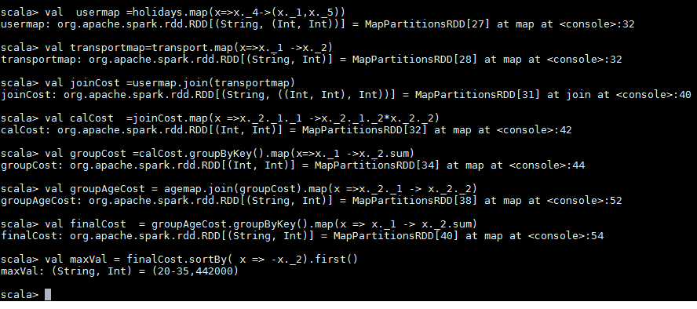

**2) What is the amount spent by each age-group, every year in travelling?**

val userholidays = holidays.map(x=>x._4 -> (x._1,x._5,x._6))

val usertransport = transport.map(x=>x._1->x._2)

val join1 = userholidays.join(usertransport)

val costdistamount = join1.map(x=>x._2._1._1 ->(x._2._1._3,x._2._1._2*x._2._2))

val join2 = agemap.join(costdistamount).map(x=>(x._2._1,x._2._2._1) -> x._2._2._2)

val expeachagegroup = join2.groupByKey().map(x=>x._1->x._2.sum)

**output screen**

